Kyle Janka

Web Development

Project 1 – Design

**Strategy Section**

**Description**

The site I choose to create will be a travel site for families, newlyweds and retired couples. Offering people popular locations to travel to. This will include pictures from the different locations showing off great destinations to visit while on vacation. The site will offer descriptions of different activities for the travelers to partake while on their trip. Each page will have a vacation(s) that is targeted towards the type of traveler (Honeymoon, Family and Retired). The honeymoon vacation will have destinations that fit well for couples that want a romantic getaway. Destinations can include highly rated restaurants, live entertainment. For the family vacation the trip will include popular destinations like amusement parks, live entertainment and activities for all ages. For the retired trip the destination will be cruises traveling around the globe to many locations, all the amenities will be on the ship and the locations the traveler will visit.

**Persona 1**

**Mr. & Mrs. Johnson**

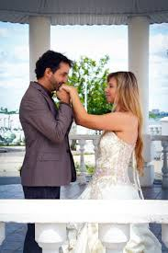 James and Mary are a newlywed couple seeking to travel for their honeymoon. They both come from the city life so they are hoping to escape the craziness of the city and escape for their vacation. They both enjoy adventure and nature and would love to have an oppurtunities to incorporate that into their vacation.

Trip Goals:

* (U1) They want adventure (hiking, sightseeing).
* (U2) Wanting to escape the busy city life (cabin, private dinners).
* (U3) James hates flying so alternative traveling options needed.

**Persona 2**

**The Smith Family**

 Tony and Sandra Smith with their two children Lindsay and Leo are your typical loving family. They enjoy traveling in the summer when the kids are out of school. Leo and Lindsay are huge rollercoaster fans and love when they go to amusement parks. Tony and Sandra enjoy the live entertainment that is friendly for the whole family.

Trip Goals:

* (U4) They are looking for amusement parks with rollercoasters.
* (U5) The family will want to enjoy live entertainment that is family friendly.
* (U6) The children usually do not like long car rides and like to travel quickly (Flight options).

**Persona 3**

**Mr. and Mrs. Levy**

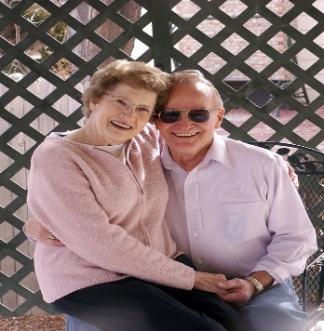 Ronald and Leona Levy have been married for 40 years and always have enjoyed traveling. They have traveled to nearly every state and have decided they wanted to relax a bit more and hit the high seas. They have not traveled to many locations outside the US and are excited to explore the options.

Trip Goals:

* (U7) Seeking a cruise that they can relax and unwind.
* (U8) Want to visit locations outside the US.
* (U9) Will need list of departure locations to find closest to them.

**Company Goals**

* (C1) Build customer excitement for trips.
* (C2) Make sure customers have a clear idea of what trip is best for them.
* (C3) Offer a streamlined experience for the customer seeking a trip.

**Scope Section**

**Requirements of Website**

* (R1 - U1) Offer a trip into the country or mountains, offering hiking opportunities and adventure.
* (R2 – U2) Display options for cabin rentals, giving the couple a private retreat.
* (R3 – U3) Offer options to travel by train or give directions to drive for all trips.
* (R4 – U4) Offer a trip to an amusement park with lots of rollercoasters.
* (R5 – U5) The amusement park must off live entertainment options for the family.
* (R6 – U6) Be sure to have options to travel by plane for all trips.
* (R7 – U7) Offer a trip for a people to travel on a luxury cruise with many amenities.
* (R8 - U8) Make sure the cruise vacation visits locations outside the US.
* (R9 - U9) Have a list of departure locations for the cruise displayed.
* (C1 – U1) Display pictures of the different trips and attractions to build excitement.
* (C2 – U2) With all descriptions be precise and detailed so the customer fully understands the trips.
* (C3 – U3) Do not add too much to the trip pages, make them detailed, easy to follow and offer links to book a trip.

**Structure Section**

Home

Trip 1 Trip 2 Trip 3

Travel Pics Booking Travel Pics Booking Travel Pics Booking

Travel Options

Flying Train Driving

I decided to go with this structure since it was straight to the point. A user would decide on which trip they enjoy, they have the option to go to a page to see more pictures of the trip, they will have a link to book the trip (Hotel/Cabin, Amusement Park, Cruise) and a link taking them to a travel option page. On the travel option page, they will have options for flying, taking a train and driving. This layout is simple and easy to follow causing very little confusion on the end user side.

**Wireframe Section**

